
Department of Computer Engineering & Technology
CSE --- LEVEL 1
Capstone Project Synopsis

Group No. | Name | PRN | Email | Mobile No. | Panel | Signature
P12 | Taha Kapadia | 1032222679 | 1032222679@mitwpu.edu.in | 7385902646 | H
 | Pranjal Vishwakarma | 1032222756 | 1032222756@mitwpu.edu.in | 7987447536 | H
 | Saket Sontakke | 1032222648 | 1032222648@mitwpu.edu.in | 8669618813 | H
 | Akshat Srivastava | 1032222619 | 1032222619@mitwpu.edu.in | 9309456398 | H

Project Title: Thermal-Aware Load Balancing Using Physics-Informed Neural Networks (PINN)
Project Domain: AIML, Computer Networks, Edge Computing, Distributed Systems, Green
Technology, Cyber-Physical Systems (CPS)
Name of the Company (for Industry Supported Project only): N/A
Name of the External Guide (for Industry Supported Project only): N/A
Inhouse Project: Yes

Abstract:
In the current age of high-density distributed computing, the performance of computational clusters is constrained by poor thermal management. This project proposes a new framework for Physics-Informed Thermal-Aware Load Balancing, an architecture built to balance high-performance execution with the thermal/heat limitations of processing nodes. By doing so, the health and reliability of the hardware are prioritized alongside performance and efficiency.
Traditional load balancing mechanisms are usually “thermal-blind”. Typical schedulers only optimize for performance based on metrics such as latency and throughput. Temperature issues are often handled once they arise either through throttling the processor or through using simple heuristics (if-else conditions) to reroute the traffic. As a result, when a processor is under heavy load and approaches its thermal limit, it will throttle its processing speed and cause a latency spike that propagates through the entire computing network. Current computing infrastructures generally lack a foresight into the effects of thermal behaviour and will only react to heat issues after the integrity of the hardware has already been compromised. Using a “Physics-Informed Neural Network (PINN)” approach to manage computing resources will replace reactive triggers with proactive actions to ensure hardware sustainability without sacrificing performance.
Software:
Category | Tools & Frameworks | Key Purpose
Machine Learning & Modelling | Python, PyTorch | PINN architecture and model training
Computation | NumPy, SciPy | Data generation and optimized model execution
Frontend/UI | Next.js, React, Three.js | Real-time system & thermal visualization
Backend API | FastAPI | Serving real-time load balancing decisions via REST
Testing & Quality Assurance | PyTest, FastAPI TestClient | Unit testing and API validation of requests/responses
Data & Storage | MongoDB Atlas | Persistence for logs and experiment results
Cloud & DevOps | Vercel, Hugging Face, Git | Full-stack deployment and version control

Hardware:
- Development and testing on standard personal computers
- Training on local GPU or Google Colab (CPU/GPU)
- No specialized hardware sensors are required

High-Level Design (HLD):
A cluster of processing nodes with limited cooling capacity, responsible for processing incoming computational workloads (tasks/jobs), not raw network packets.
1. Workload and Thermal Data Generator
- Generates workload arrival rates (tasks per second)
- Maps workload intensity to CPU utilization
- Simulates temperature evolution using simplified thermal equations
- Produces time-series data for workload, latency, and temperature
2. Physics-Informed Neural Network (PINN)
- Inputs: workload intensity, CPU utilization, ambient temperature, time step
- Outputs: predicted processing latency and node temperature
- Physics constraints enforced during training:
  - Temperature increases with increasing load
  - Temperature evolves smoothly over time (thermal inertia)
  - Latency increases with congestion
The PINN is trained once offline, validated, and frozen for inference.
3. Thermal-Aware Load Balancing Module
- Uses PINN predictions to evaluate load balancing decisions
- Assigns incoming workloads based on predicted latency and thermal scores
- Prevents workload assignment to nodes approaching thermal limits
- Enables comparison with traditional latency-only load balancing strategies
4. Visualization Dashboard and User Interface
- Interactive dashboard for non-technical users
- Displays node temperature, workload distribution, and load allocation decisions
- Abstracts all underlying physics and machine learning details

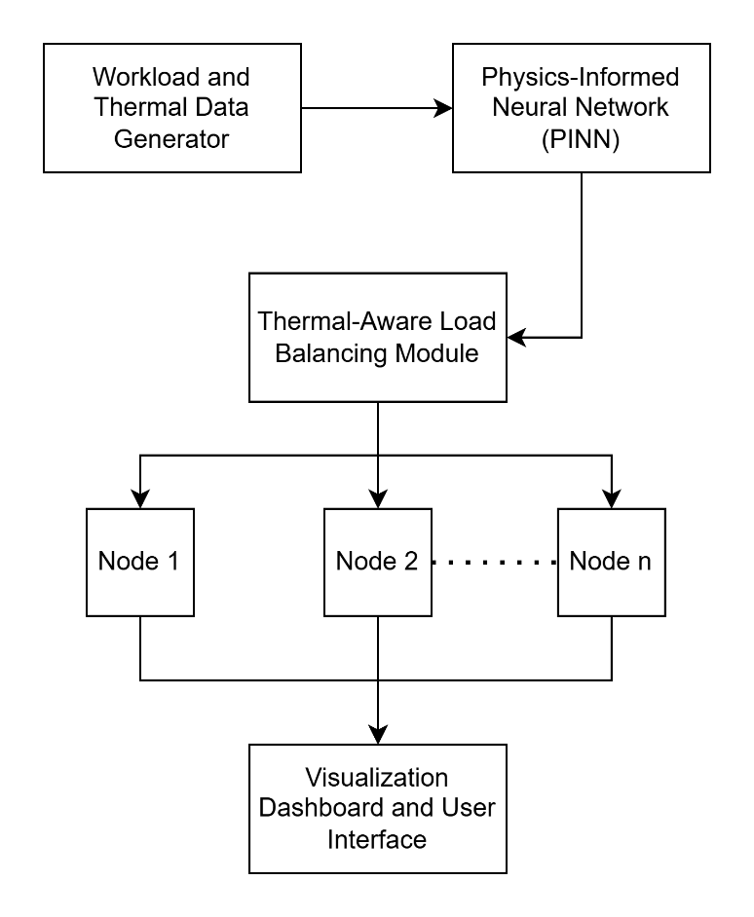
Block Diagram

